Module 6
WebAPI
Exercise 3
- Code
Models/Employee.cs
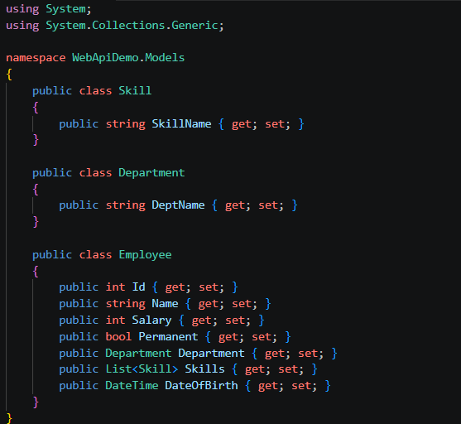

Filters/CustomAuthFilter.cs
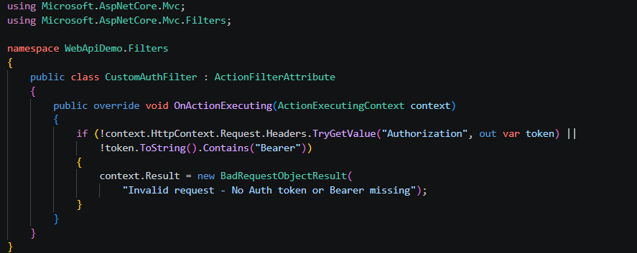

- Output
Unauthorize (Status Code 401)
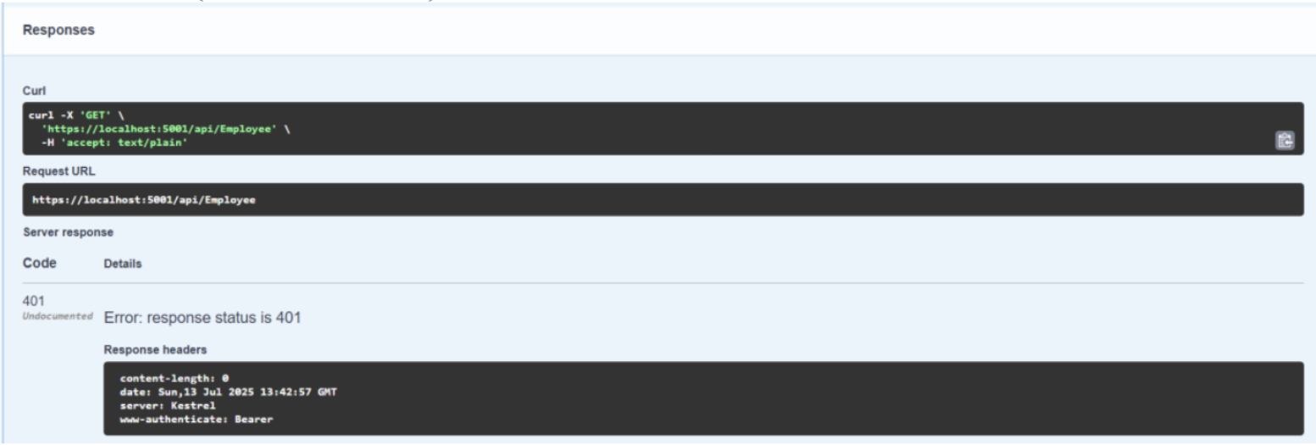

Authorize(Status Code 200)
